 

file 1325920: Average machine count per day is: 3.250

file 1325920: Standard deviation is: 3.279

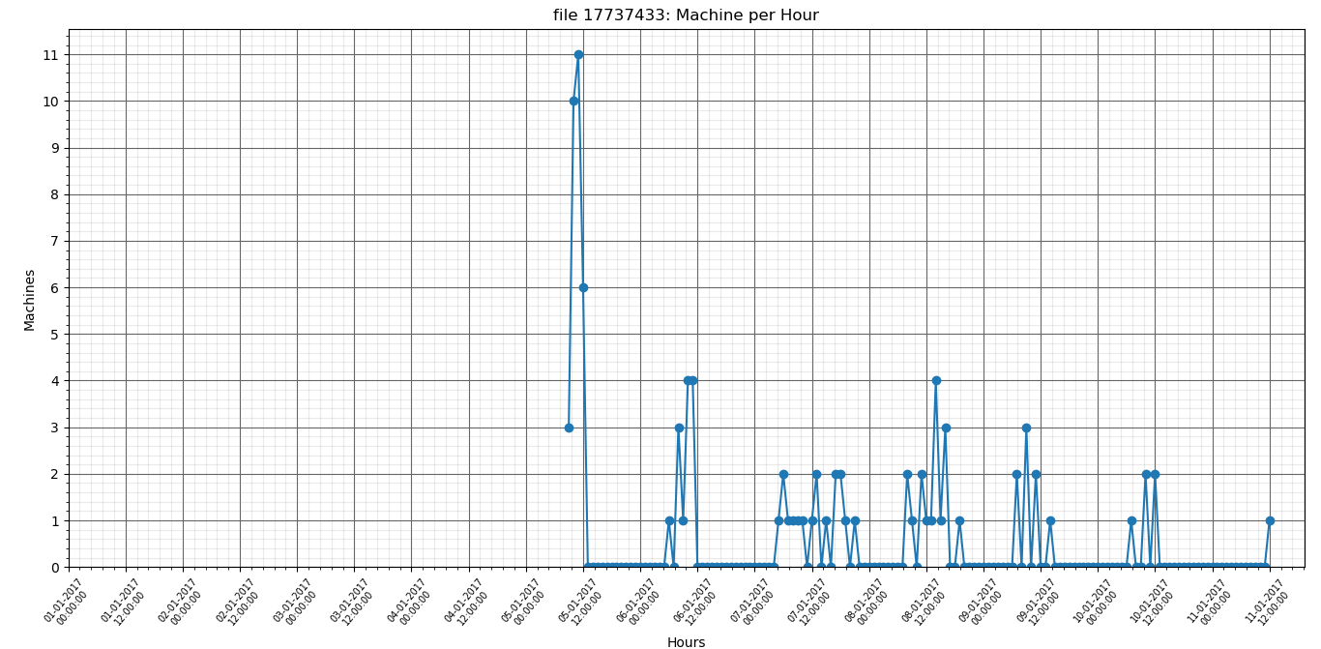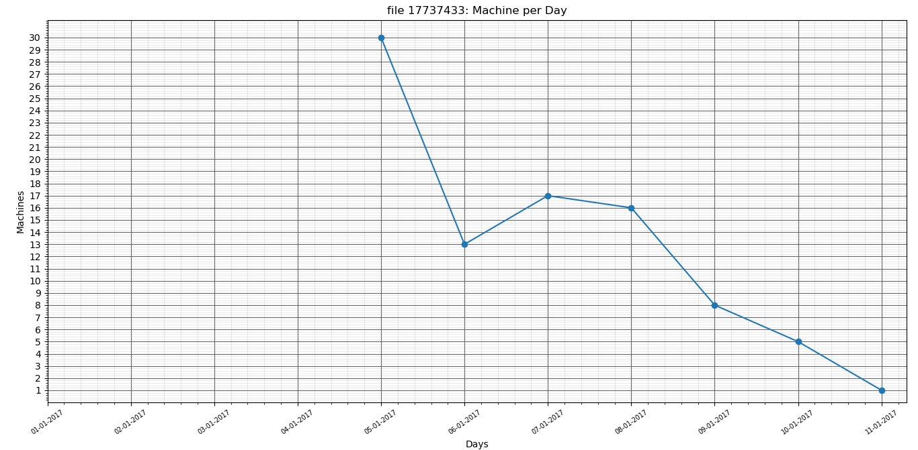

file 17737433: Average machine count per day is: 7.500

file 17737433: Standard deviation is: 9.672

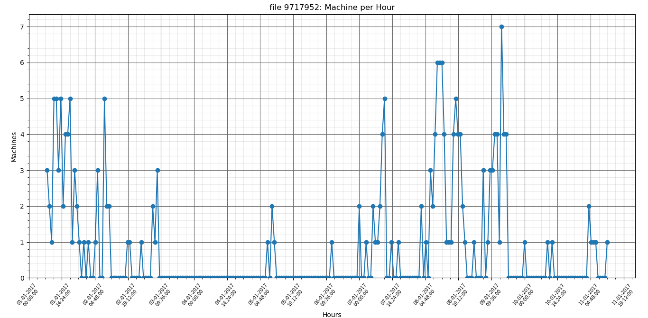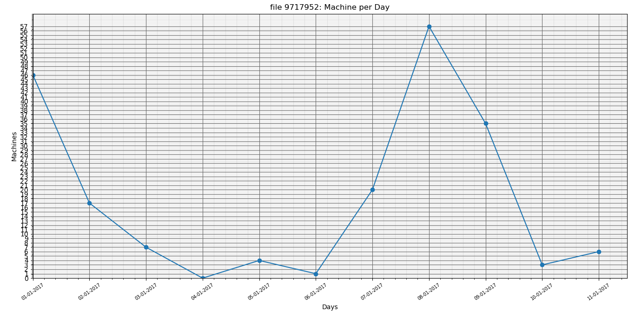

file 9717952: Average machine count per day is: 16.333

file 9717952: Standard deviation is: 19.514

**תקין**

4676898

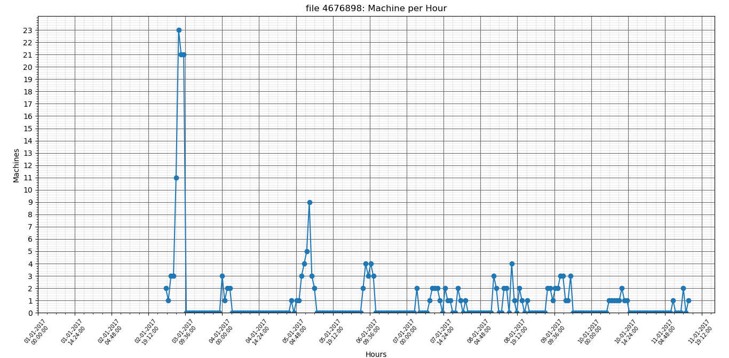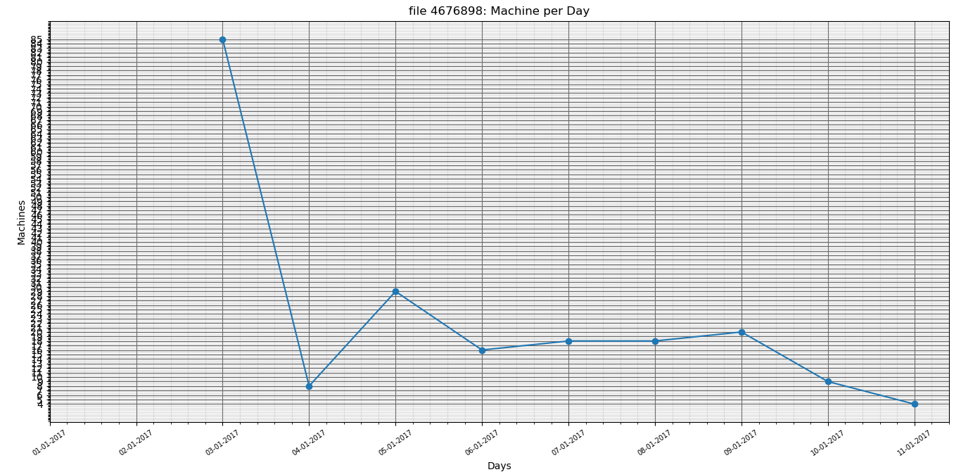

file 4676898: Average machine count per day is: 17.250

file 4676898: Standard deviation is: 23.277